**The Innovations in the Music of Stravinsky’s ‘Russian Period’**

Originating from Russia, Stravinsky was one of the most prominent and influential composers of the twentieth century. During his Russian period, he started his compositional studies with Rimsky-Korsakov, who played a crucial role in influencing Stravinsky’s music.[1] Non-Western scales and large orchestration were the important influences from Rimsky-Korsakov, these elements can be found in his works during the early Russian period.[2] Besides that, Stravinsky also discovered innovative new ideas in rhythm and harmony during the later years after Rimsky-Korsakov’s death, such as irregular rhythm, ostinato; which can be seen in *the Rite of Spring* (1913), and bitonality in *Petrushka* (1911). This essay will talk about the ingenious innovations, which can be seen in the music of Stravinsky’s Russian period.

The most important innovation in Stravinsky’s music is rhythm. There is no doubt to say that all the great rhythmic innovations were developed and presented in *the Rite of Spring*.[3] However, *Petrushka* was the start of the reassessment of rhythm in twentieth-century music.[4] Figure 1 shows the rapid change of time signatures and the use of different time signatures in the same place at Rehearsal no.4 in the first of *Petrushka*. Figure 2 shows rhythmic ostinato pattern at Rehearsal no.65 in the third tableau of *Petrushka*.

Figure 1 Stravinsky, Petrushka, First Tableau, ‘The Shrovetide Fair’, Rehearsal no.4

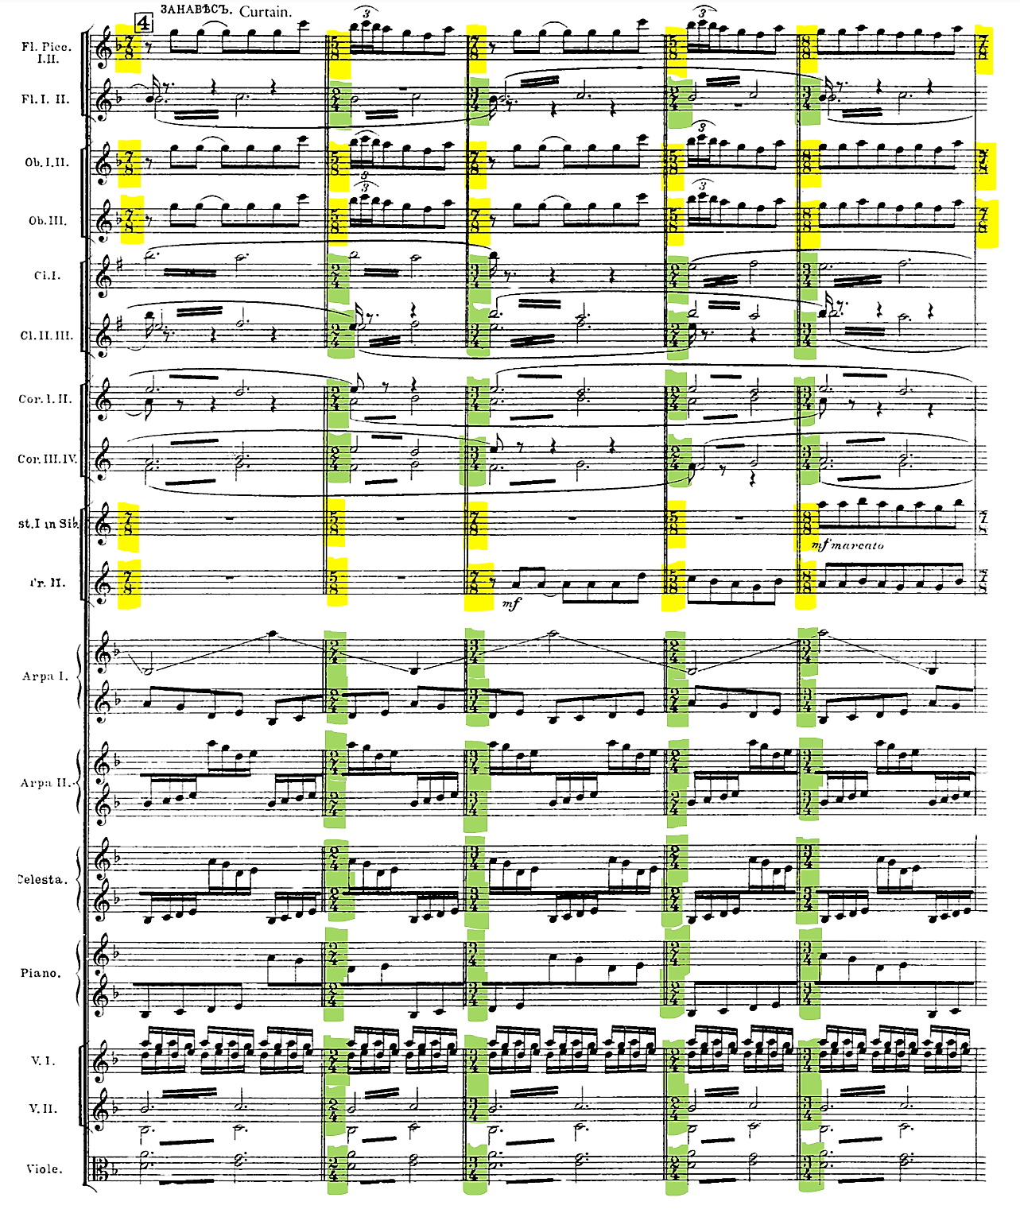

Figure 2 Stravinsky, Petrushka, Third Tableau, ‘The Moor’s Room’, Rehearsal no.65

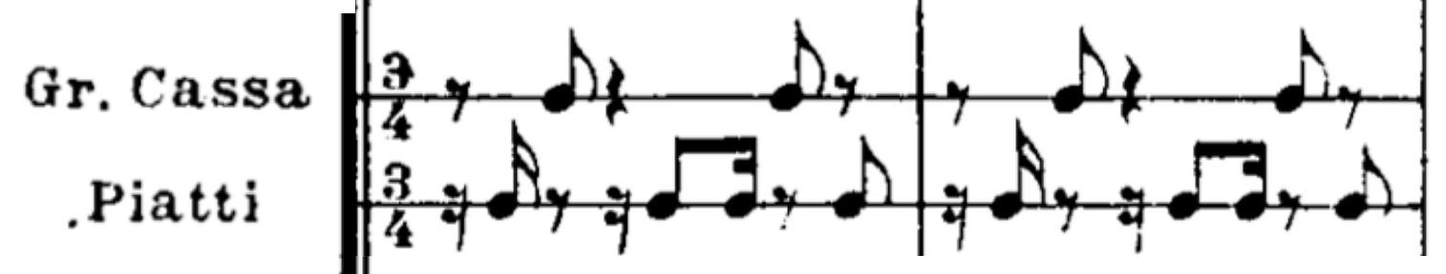

In the Rite of Spring, there are two basic aspects of the rhythmic language.[5] The first is the use of ostinato, and another, the use of metric irregularity.[6] ‘Ritual Action of the Ancestors’ from part two is a great example to demonstrate the use of ostinato, this example shows in figure 3.

Figure 3 Stravinsky, the Rite of Spring, Part 2, ‘Ritual Action of the Ancestors’, Rehearsal no.129

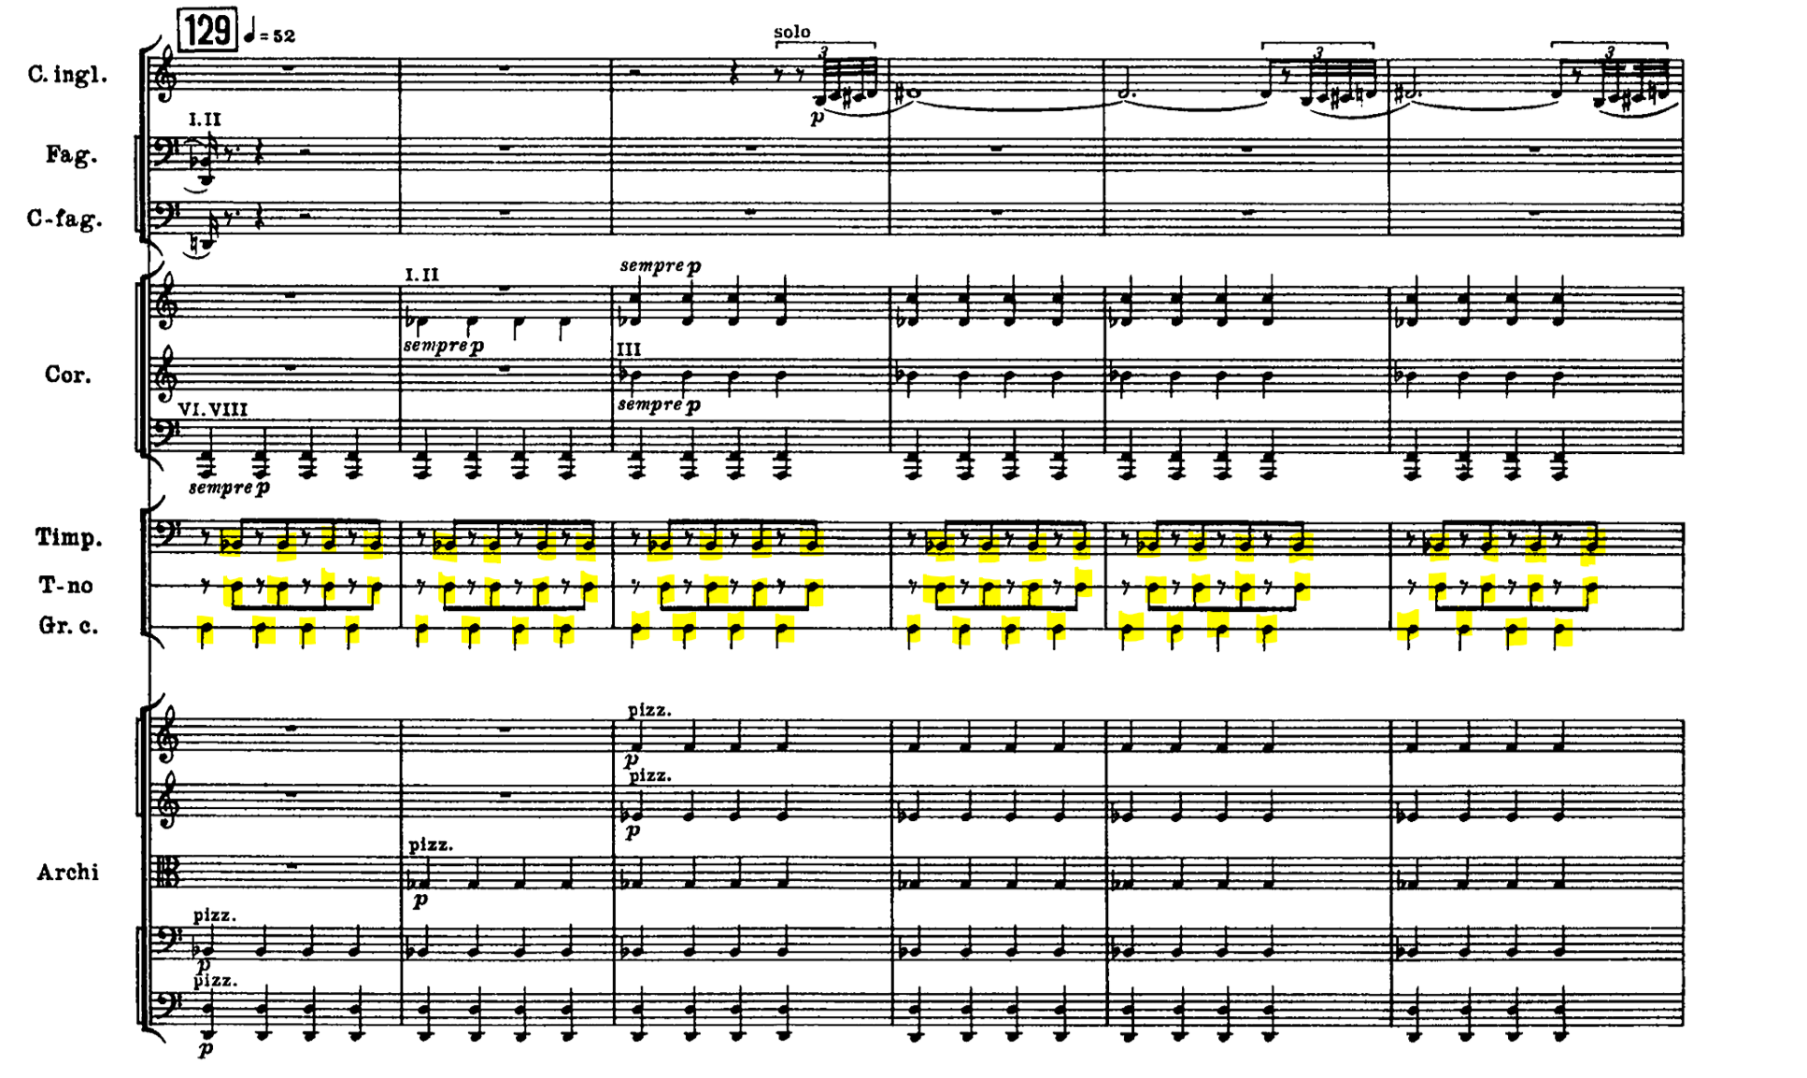

Of course, Stravinsky’s rhythmic language developed more than that. He also used polyrhythm in the use of ostinato, such as his various superimposition on multiple ostinatos with different rhythmic values and unequal total durations, to produce more advanced rhythm.[7] For example, at Rehearsal no.16 in ‘Dances of the Young Girls’ from part one features the superimposition of three ostinatos. Figure 4 shows the first motif in English horn, the second in violas, and the third in basses and cellos.

Figure 4 Stravinsky, the Rite of Spring, Part 1, ‘Dances of the Young Girls’, Rehearsal no.16

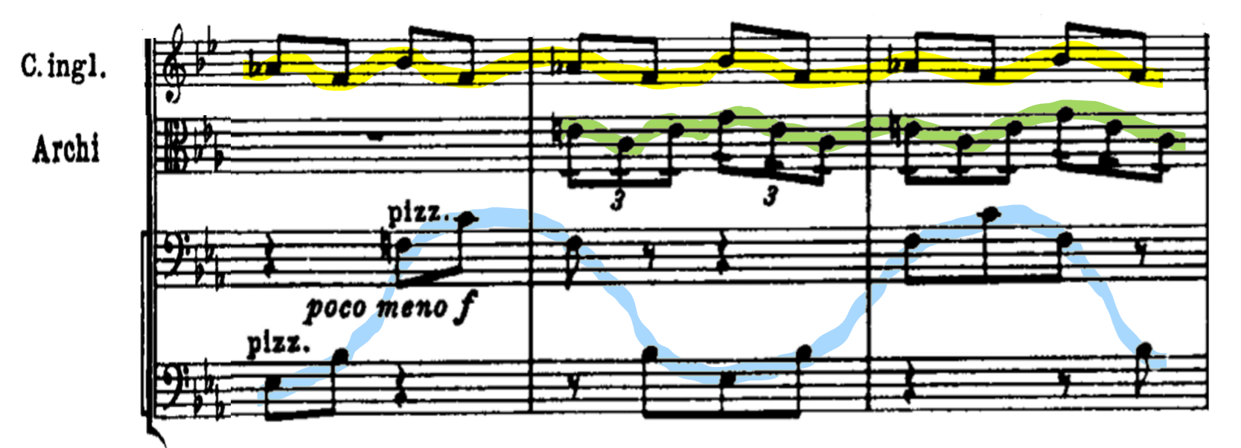

On the other hand, the use of metric irregularity is another prominent compositional technique by Stravinsky. This is the rhythm of irregularly spaced downbeats, with variable metric barring in the notation.[8] The string ostinato at the beginning of ‘Daces of the Young Girls’ showed a great example of this technique. It has regular barring, but the irregular accented chords grouped as 9+2+6+3+4+5+3 create the disruptive quality and the effect of metric irregularity. The beginning of ‘Dances of the Young Girls’ is shown in figure 5.

Figure 5 Stravinsky, the Rite of Spring, Part 1, ‘Dances of the Young Girls’, Rehearsal no.13

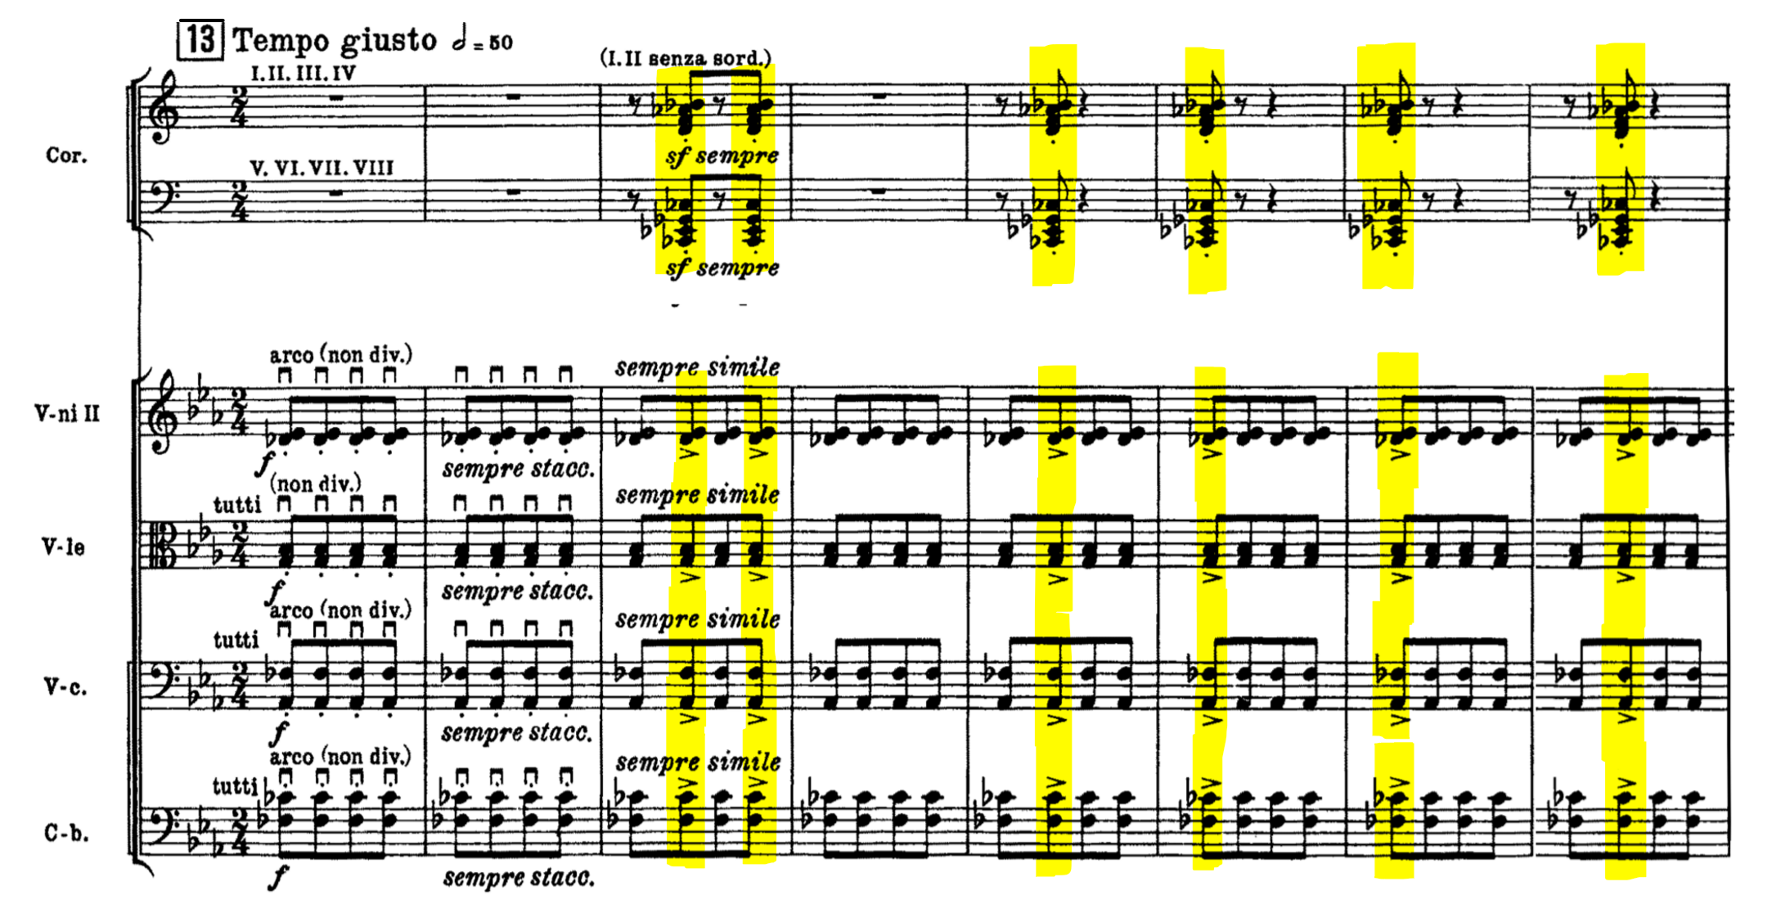

Besides that, ‘Sacrificial Dance’ from part two has the same rhythmic feature too. The beginning of the music presents the variable downbeats technique, which creates a distinguish pulse, but the time signatures constantly and rapidly change.[9] The figure 6 shows strings in the beginning of ‘Sacrificial Dance’.

Figure 6 Stravinsky, the Rite of Spring, Part 2, ‘Sacrificial Dance’, Rehearsal no.142-143

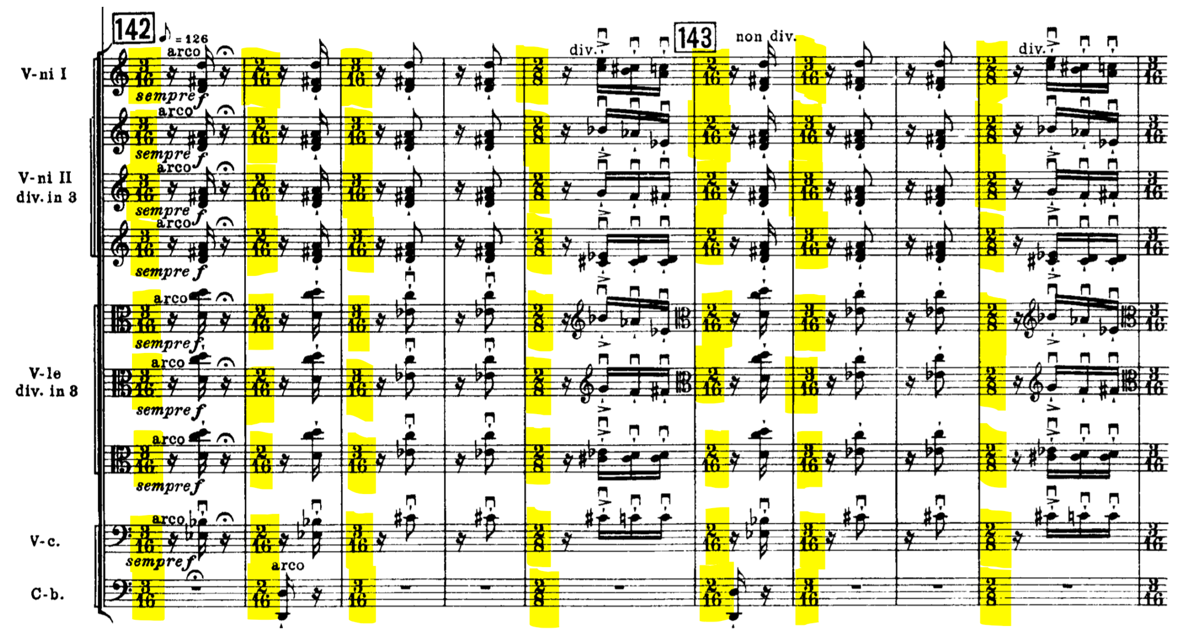

Additionally, Stravinsky also discovered more in his rhythmic language, which is the combination of these two rhythmic aspects.[10] This technique can be found in ‘Dances of the Young Girls’ too, however ‘Sacrificial Dance’ is a better example. In fact, the whole ‘Sacrificial Dance’ presented all of Stravinsky’s rhythmic techniques from his Russian-period, which produced the rhythmic complexity that never happened before.[11] The figure 7 shows an example at rehearsal no.149, which presents the irregular pattern of rhythmic ostinato, with alternatively change of 3/8 time and 2/8 time.[12]

Figure 7 Stravinsky, the Rite of Spring, Part 2, ‘Sacrificial Dance’, Rehearsal no.149-150

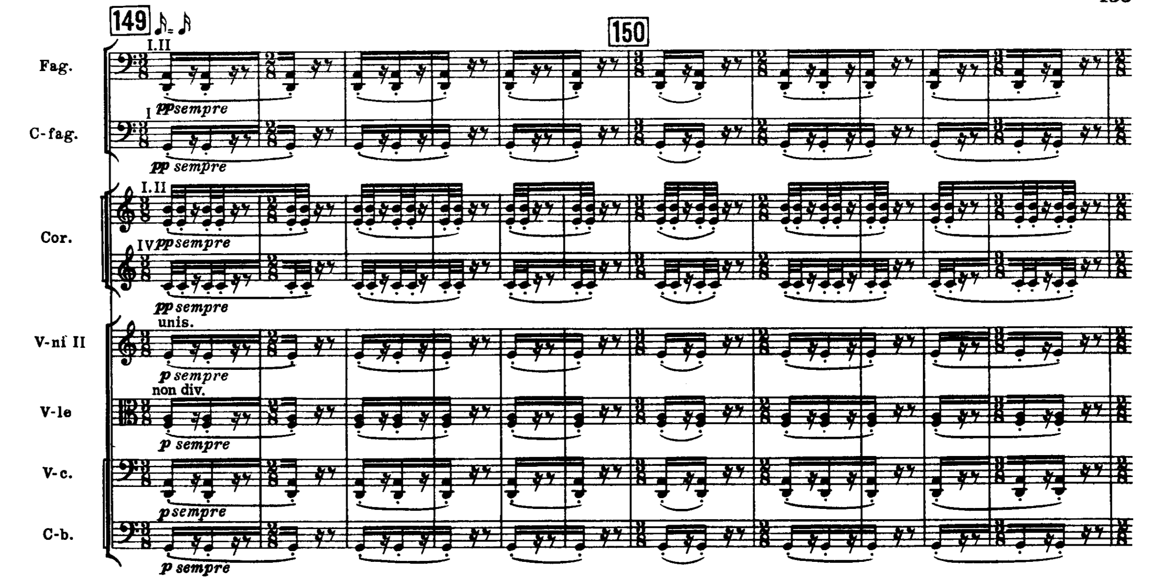

In the context of harmony, Stravinsky used many different collections, such as diatonic, octatonic, and other collections. The most notable one in Stravinsky’s harmony language is Octatonicism. Octatonicism was originally used by Stravinsky’s teacher; Rimsky-Korsakov. Following so, Stravinsky decided to explore more of it by his own accord. Octatonic scale, known as Korsakovian scale, is formed by alternating semitones and tones, this scale can begin with the semitone or the tone.[13] According to Van den Toorn, there are only three transpositions which are possible; which means we can only transpose within these collections, which can be seen in figure 8.[14]

Figure 8 Octatonic three transpositions

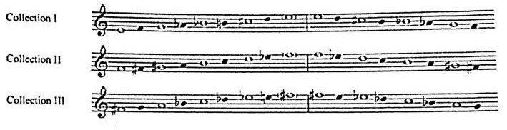

In the second tableau of Stravinsky’s *Petrushka*; an octatonic collection had become a stable point to support the whole span of the work done, despite the tonal digressions along the way.[15] The well-known dissonant chord combines two superimposed triads with roots augmented fourth apart, which are C major and F-sharp major, also known as the “Petrashka Chord”.[16] These chords can be found in the Collection III of the octatonic collections mentioned previously. Moreover, with the “Petrushka chord”, it shows that Stravinsky had discovered bitonality and thus, used it greatly in his work, which is a very important innovation to mention. The “Petrushka chord” is shown in figure 9.

Figure 9 “Petrushka Chord”

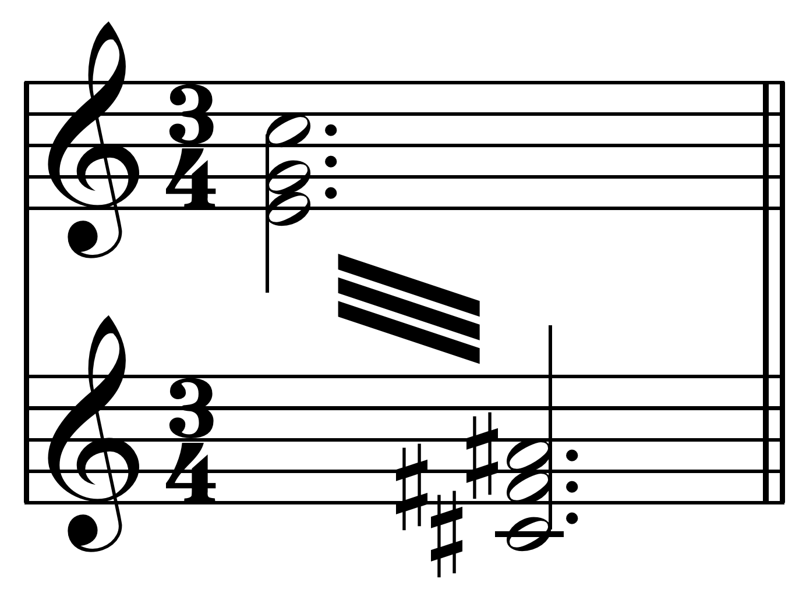

Besides *Petrushka*, *the Rite of Spring* has the similar use of bitonality. In ‘Augurs of Spring’, there is a famous chord called “Augurs chord”, which consists of F-flat major and a dominant seventh chord built on E-flat major.[17] However, Tymoczko argued that the chord is obviously non-octatonic, which also does not appear in the octatonic collection.[18] The “Augurs chord” is shown in figure 10.

Figure 10 “Augurs Chord”

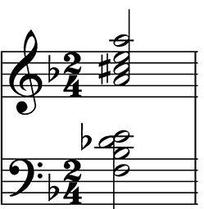

Furthermore, Stravinsky also explored the interactions between the octatonic and diatonic sets. Which means the music has octatonic and diatonic sets played together in the same passage. In Stravinsky’s music, it is not common that superimpositions involve two or more octatonic collections.[19] Normally, it is for one octatonic transposition to succeed another, and to do so at a distance.[20] This unique compositional style creates the feeling of blurred and unstable tonality, and we can usually find it in Stravinsky’s Russian-period works. In the first tableau of *Les Noces*, at Rehearsal no.11, it used Collection II of the octatonic collections for Piano I and III, and the solo bass, against with Dorian scale on B in the solo soprano.[21] In addition, the solo bass, and Piano I and III are actually superimposed, although they are from the same collection. The figure 11 shows the octatonic-diatonic interactions at Rehearsal no.11 in the first tableau of *Les Noces*.

Figure 11 Stravinsky, Les Noces, First Tableau, Rehearsal no.11

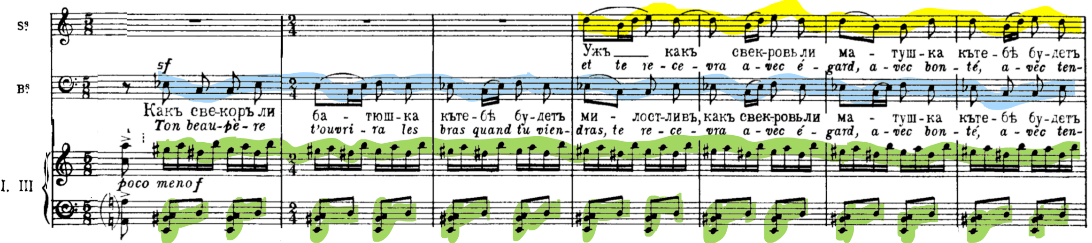

Stravinsky’s orchestration in the Russian-period works is another significant innovation. Rimsky-Korsakov’s orchestrations tend to be large and colorful, and since Stravinsky was his student; strongly influenced Stravinsky’s orchestration to be likewise. For example, *the Rite of Spring* calls for the largest orchestra Stravinsky ever composed. The score calls for one piccolo, three flutes (third doubling second piccolo), one alto flute, four oboes (fourth doubling second English horn), English horn, three clarinets in B and A (third doubling second bass clarinet), clarinet in E and D, one bass clarinet, four bassoons (fourth doubling second contrabassoon), one contrabassoon; eight horns (seventh and eighth doubling tenor tubas), trumpet in D, four trumpets in C (fourth doubling bass trumpet in E♭), two trombones, one bass trombone, two bass tubas; a percussion section with 5 timpani (requiring two players), bass drum, tam-tam, triangle, tambourine, cymbals, antique cymbals, guiro, and strings.

According to Scherliess, Stravinsky treats solo instruments as equals within the ensemble, also features some non-solo instruments as an important role in the music, and sometimes he composed for some instruments in unconventional way. [22] For example, the solo bassoon from Introduction of *the Rite of Spring* is written in high register, which create pale and weak tone, this example shown in figure 12.

Figure 12 Stravinsky, the Rite of Spring, Part 1, ‘A Kiss of the Earth’, Introduction

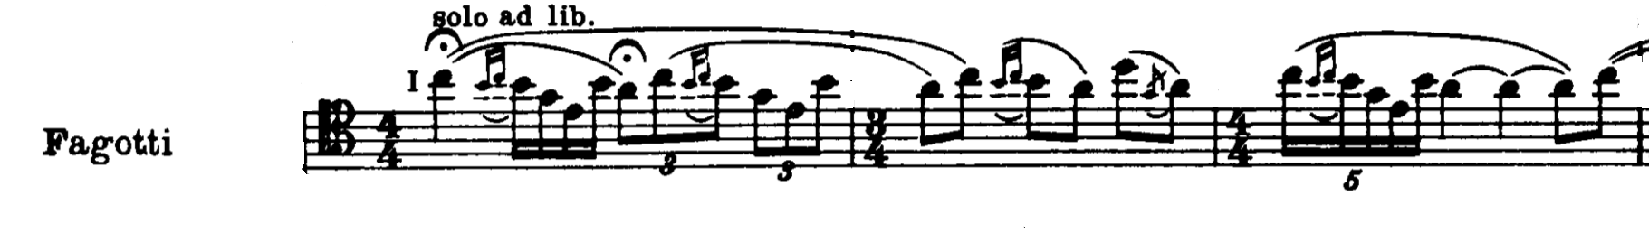

Besides that, Stravinsky’s preference of timbres usually tends to be dry and percussive.[23] For example, at the beginning of ‘Dances of the Young Girls’, when the irregular accents happened, it sounds as though a snare drum or tenor drum is playing along. In reality, this whole passage only had horns playing when the irregular accents happened, and strings playing with only downbows, with staccatos marked in to create dry tone.

Moreover, Stravinsky’s extreme use of performance indications for orchestral instrument is notable too. From this aspect, Stravinsky obviously knew the colors and effects of each instrument, and was trying to push the instruments to their limits. For example, the harmonics on open strings, sul ponticello and col segno in strings, and flutter tonguing in woodwinds. Figure 13 shows sul ponticello and col segno used in strings at Rehearsal no.70 in ‘Procession of the Oldest and Wisest One’, and figure 14 shows flutter tonguing used in woodwinds at Rehearsal no.33 in ‘Dances of the Young Girls’.

Figure 13 Stravinsky, the Rite of Spring, Part 2, ‘Procession of the Oldest and Wisest One’, Rehearsal no.70

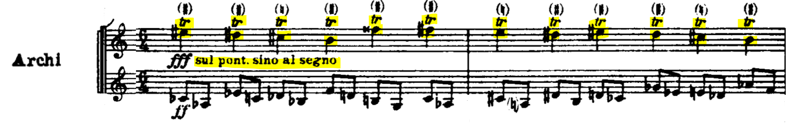

Figure 13 Stravinsky, the Rite of Spring, Part 1, ‘Dances of the Young Girls’, Rehearsal no.33

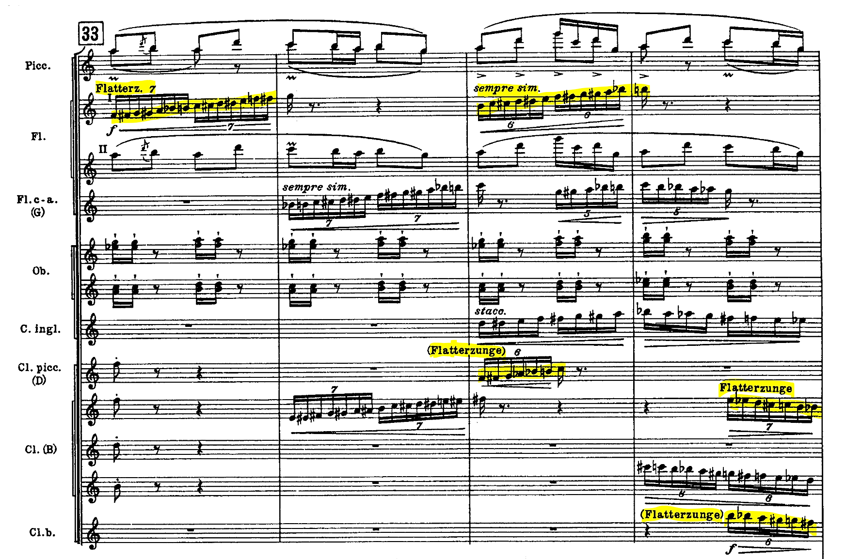

In conclusion, the innovations that Stravinsky introduced, such as metric irregularity, bitonality, and large and dry orchestration, had a huge impact on later composers, especially in the aspect of rhythm. Besides that, Stravinsky as a nationalist, also largely used traditional Russian elements as his melodic ideas in his works, with most of the elements borrowed from Rimsky-Korsakov’s collection of Russian folksongs. After his Russian period, Stravinsky continued to use these techniques throughout his career.[24] In his later years, Stravinsky explored more about neoclassical music and serial music. However, the most important was Stravinsky’ Russian-period works, which were the beginning of modern music, and which inspired many modern composers.

Bibliography

Online Articles

1. Wilson, Charles: ‘Octatonic’, Grove Music Online (Oxford University Press, 2001), accessed 22 March 2018, <https://doi.org/10.1093/gmo/9781561592630.article.50590>
2. Walsh, Stephen: ‘The early Diahilev ballets: Stravinsky, Igor’, *Grove Music Online* (Oxford University Press, 2001), accessed 22 March 2018, <https://doi.org/10.1093/gmo/9781561592630.article.52818>
3. Tymoczko, Dmitri: ‘Stavinsky and the Octatonic: A Reconsideration’, Music Theory Spectrum (Oxford University Press, 2001), accessed 22 March 2018, <http://www.jstor.org/stable/10.1525/mts.2002.24.1.68>

Books

1. P.Morgan, Robert: *New Tonalities*, *Twentieth-Century Music* (New York: W.W. Norton and Co., 1991)
2. Cross, Jonathan: *The Stravinsky Legacy* (Cambridge: Cambridge University Press, 2001)
3. Van Den Toorn, Pieter C., and McGinness, John: *Octatonic scale, Stravinsky and the Russian Period* (Cambridge: Cambridge University Press)
4. Taruskin, Richard: *Music in the Early Twentieth Century* (New York; Oxford: Oxford University Press, 2005)
5. Gloag, K: *Russian Rites: Petrushka, The Rite of Spring and Les Noces*, *The Cambridge Companion to Stravinsky*, ed. Cross, Jonathan (Cambridge: Cambridge University Press, 2003)
6. Scerliess, Volker: *Instrumentation, Igor Stravinsky und seine Zeit* (Laaber: Laaber-Verlag, 1983)
7. Burkholder, Peter J, Grout, Donald Jay, and Palisca, Claude V: *A History of Western Music*, 9th edition. (New York and London: W.W. Norton and Co., 2014)

Music score

1. Stravinsky, Igor: *Petrushka* (Berlin: Editions Russes de Musique, 1912)
2. Stravinsky, Igor: *The Rite of Spring* (Moscow: Muzyka, 1965)
3. Stravinsky, Igor: *Les Noces* (London: J.&W. Chester, 1922)

1. P.Morgan, Robert: *New Tonalities*, *Twentieth-Century Music* (New York: W.W. Norton and Co., 1991), 90.
2. *Ibid.*
3. Cross, Jonathan: *The Stravinsky Legacy* (Cambridge: Cambridge University Press, 2001), 85.
4. *Ibid*, 84.
5. Cross, Jonathan: *The Stravinsky Legacy*, 85.
6. *Ibid.*
7. P.Morgan, Robert: *New Tonalities*, *Twentieth-Century Music*, 97.
8. Cross, Jonathan: *The Stravinsky Legacy*, 86.
9. Cross, Jonathan: *The Stravinsky Legacy*, 86.
10. *Ibid*.
11. P.Morgan, Robert: *New Tonalities*, *Twentieth-Century Music*, 100.
12. *Ibid.*
13. Wilson, Charles: ‘Octatonic’, Grove Music Online (Oxford University Press, 2001), accessed 22 March 2018, <https://doi.org/10.1093/gmo/9781561592630.article.50590>
14. Van Den Toorn, Pieter C., and McGinness, John: *Octatonic scale, Stravinsky and the Russian Period* (Cambridge: Cambridge University Press), 42.
15. Taruskin, Richard: *Music in the Early Twentieth Century* (New York; Oxford: Oxford University Press, 2005), 164.
16. Walsh, Stephen: ‘The early Diahilev ballets: Stravinsky, Igor’, *Grove Music Online* (Oxford University Press, 2001), accessed 22 March 2018, <https://doi.org/10.1093/gmo/9781561592630.article.52818>
17. Gloag, K: *Russian Rites: Petrushka, The Rite of Spring and Les Noces*, *The Cambridge Companion to Stravinsky*, ed. Cross, Jonathan (Cambridge: Cambridge University Press, 2003), 79-97, 88.
18. Tymoczko, Dmitri: ‘Stavinsky and the Octatonic: A Reconsideration’, Music Theory Spectrum (Oxford University Press, 2001), accessed 22 March 2018, <http://www.jstor.org/stable/10.1525/mts.2002.24.1.68>
19. Van Den Toorn, Pieter C., and McGinness, John: *Octatonic scale, Stravinsky and the Russian Period,* 48.
20. *Ibid.*
21. *Ibid.*
22. Scerliess, Volker: *Instrumentation, Igor Stravinsky und seine Zeit* (Laaber: Laaber-Verlag, 1983), 205, 209.
23. Burkholder, Peter J, Grout, Donald Jay, and Palisca, Claude V: *A History of Western Music*, 9th edition. (New York and London: W.W. Norton and Co., 2014), 835.
24. Burkholder, Peter J, Grout, Donald Jay, and Palisca, Claude V: *A History of Western Music*, 9th edition., 836.